**Applications and pitfalls of multilocus amplicon sequencing with Oxford Nanopore technology**

Workshop by Martin Kapun, Sonja Steindl & Astra Bertelli

In this workshop we are testing different applications of multilocus amplicon-sequencing data, e.g. for species identification, species delimitation and basic phylogenetic analyses. In particular, we will investigate advantages and potential pitfalls of using Oxford Nanopore technology (ONT) for generating sequencing data. We will present AmpliPiper, our automated analysis pipeline to carry out the aforementioned applications using data from Syrphid hoverflies as an example. Participants need to bring their own laptop (with a LINUX distribution installed) and we will provide the necessary software and data in advance.

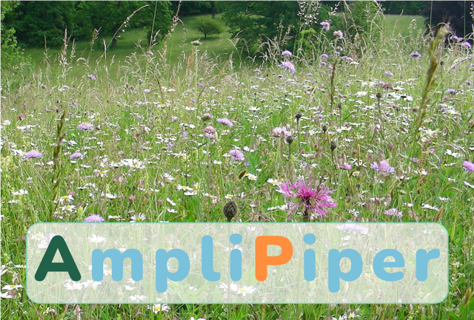

**Where and when:**

November 28th, 2024, 13:00 – 16:30 CET

Kurssaal

Natural History Museum Vienna

Burgring 7 (side entrance)

1010 Vienna

Language: English

Course fee: €40; free for NOBISts!

**www.nobis-austria.at**

**Number of participants limited!**

(10 pers. max., first come, first served)

Registration open until **November 8th, 2024**

Please use the conference registration form and send to [nicolegrunstra@gmail.com](mailto:nicolegrunstra@gmail.com) (see also [www.nobis-austria.at](http://www.nobis-austria.at))